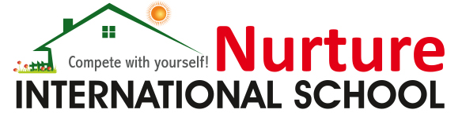

**Report on Investiture Ceremony**

Date of activity: 01-July-2023

Venue: Nurture International School, Mini Hall

Participants: Grade VIII, IX and X students

**“A great leader takes people where they don't necessarily want to go, but ought to be.”**

Nurture International School celebrated the Investiture Ceremony for the Academic Session 2023-2024 on 1st July 2023. The prestigious ceremony commenced with the Ceremonial March by the newly-elected Student Council Members and Prefects, who moved rhythmically to the beats of the band with poise and grace. The occasion was graced by the Grade X toppers of 2022-2023 as Chief Guest and Guests of Honour, and it was a wonderful gesture of the management to recognize and felicitate the toppers with this honour. Their parents also graced the occasion to witness the honours bestowed on their children and felt proud about their achievements. Mr A Narasimhan, the Chairman, was kind enough to take the time out of his busy schedule to grace the occasion, along with the navigator of our school, Principal Ms Suma H R, who were welcomed by Senior Head Girl with her wonderful speech. The choir then invoked the blessings of the Almighty, and the eminences were invited to kindle the auspicious lamp. The importance of the Investiture Ceremony was enlightened to the assembled gathering. The newly-elected Student Council Members and Prefects donned with sashes were conferred with the badges and flags by the Principal and Coordinators. The Principal administered the oath, wherein the Office Bearers pledged to uphold the duties and responsibilities to the best of their abilities. Principal inspired them with her enlightening speech. The roles and responsibilities expected of them were reiterated to the Office Bearers. The choir entertained the audience with a melodious song on the theme of ‘Leadership’.The gathering was thanked for their presence and patience by the Senior Head Boy. Saluting our motherland with the National Anthem, the Investiture Ceremony culminated with the anticipation of a hopeful year ahead.