Report on Educational trip
Date: 05-08-2023
Venue: Nandini Mega Dairy
Participants: Students of Grades 7 to 10

Everyone loves traveling to places. It is always fun to travel to different places. Traveling is always exciting, and does not matter whether we are traveling with friends, family, colleagues or strangers.
Nurture International School organized an exciting educational trip for Grades 7 to 10 students to Nandini Mega Dairy on 5th August 2023 to provide experential learning platform. The students enjoyed the transit in the bus, and learnt the process of making curd, butter, ghee, paneer, and Mozzarella and Cheddar cheese. The students got an opportunity to learn about the working of an industry, various industrial processes involved and also employability.
The students had a wonderful time traveling together with their classmates in a bus, making memories, singing, enjoying, dancing, and munching on their favourite foods. Once they reached the mega dairy, the students were explained about what happens at the industry, how the milk is collected, processed to make curd, cheese, butter, ghee and cottage cheese. The students went around the plant looking through windows at the humungous machines with awe and the workers at the conveyer belts collecting the end product.
The industrial visit was in alignment with the core objective of the National Education Policy, NEP 2020 i.e development of 21st century skills such as analytical skills, critical thinking skills among students at the school level.
These educational trips are very important for the students as they learn outside the classroom. Apart from learning something new or exciting related to workings of the society or industry, they also learn to be self reliant and responsible. Overall, this was a wonderful trip for the students.
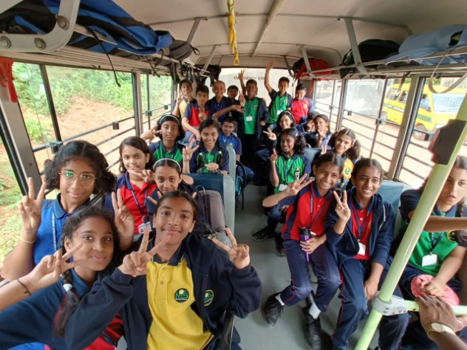 | 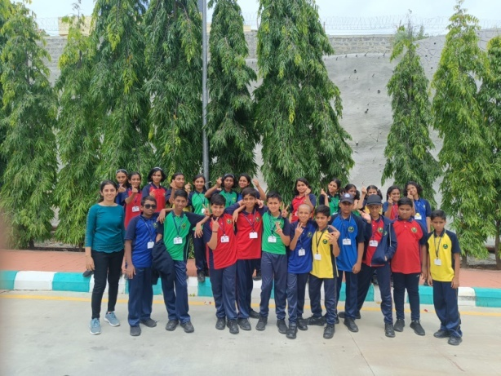
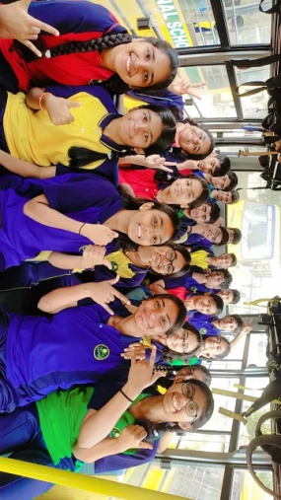 | 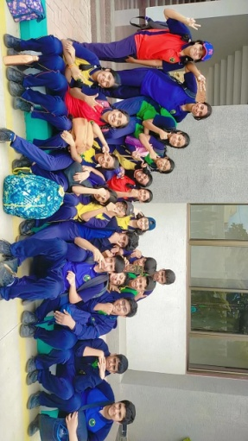
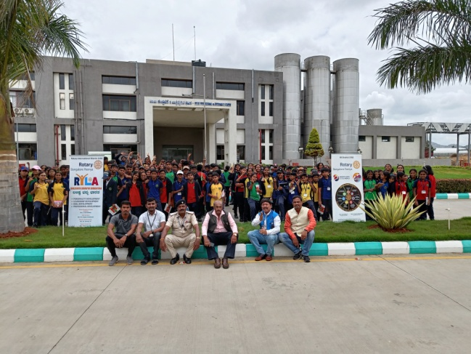 | 